Coding Assessment:
The purpose of this document is to initiate a requirement to request candidates to prepare for a codebase for further interviews and manager’s recruitment decisions.
Candidates are required to complete the code by themselves and submit the code back to us for evaluation with in 24hrs. Source code must be uploaded to public repositories such as Github, Dropbox, or Google Drive, with its link sent back to us. Code should be functional, meaning we should be able to compile and run. There should be a readme file explaining steps to run the application also.
Tech Stack:
JavaScript or TypeScript, WebdriverIO v9 and Cucumber.

Manual Test steps
Step No. | Action
1 | Open the URL “https://www.medavie.ca/en/”
2 | From the homepage, Click on “Contact” Menu
3 | Verify Contact Page is displayed  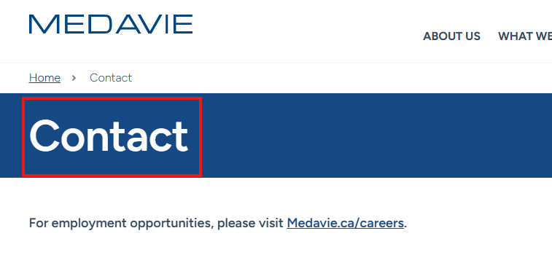
4 | Verify the Information on Medavie Blue Cross Section  Atlantic Region: 1-888-227-3400  Quebec: 1-888-588-1212  Ontario: 1-800-355-9133  Elsewhere in Canada: 1-800-667-4511  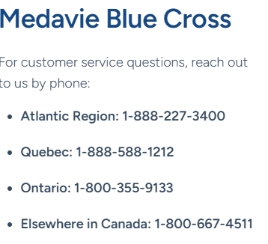
5 | Close the Browser

Repeat same test for French
Step No. | Action
1 | Open the URL “https://www.medavie.ca/fn/”
2 | From the homepage, Click on “Coordonnées” Menu
3 | Verify Contact Page is displayed  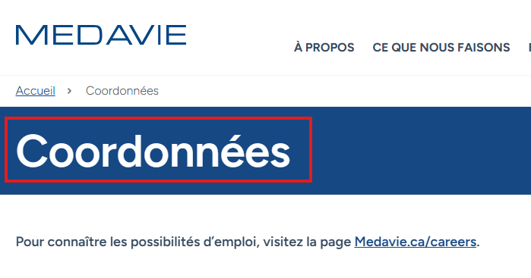
4 | Verify the Information on “Croix Bleue Medavie”  Région de l’Atlantique : 1-888-227-3400  Québec : 1-888-588-1212  Ontario : 1-800-355-9133  Ailleurs au Canada : 1-800-667-4511  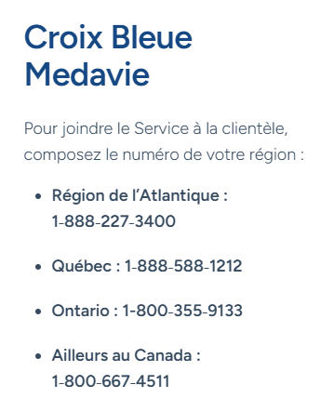
5 | Close the Browser

